KELOMPOK

* Fikrullaily Uly Yachsyi
* Novaldy Refi Nugita
* Rushpika Rachardika
* Sahruli Nur rizky

Langkah pertama yang dilakukan adalah

1. Membuat Local Field untuk tabel Funds Transfer
2. Masuk dengan menggunakan “LOCAL.TABLE”

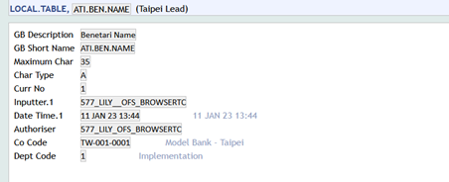

GAMBAR ATI.BEN.NAME dalam LOCAL.TABLE

GAMBAR ATI.PAYMENT.DETAILS dalam LOCAL.TABLE

VERSION NAME: FUNDS.TRANSFER,ATI.CASH

ENQUIRY NAME: ATI.EN.FT.CASH

TEMPLATE TABLE: ATI.TH.FT.CASH.WITHDRAWL

PEMBUATAN VERSION

AUTOMATIC DEFAULTING



CHECK ID

SEBELUM MASUKIN KE VERSION PASTIKAN ROUTINE TELAH TERDAFTAR PADA EB.API

* ROUTINE CHECK ID

* ROUTINE AUTOMATIC DEFAULTING

Daftarkan pada PGM.FILE

* PGM.FILE

ENQUIRY

* DATA FIELDS KE DUA

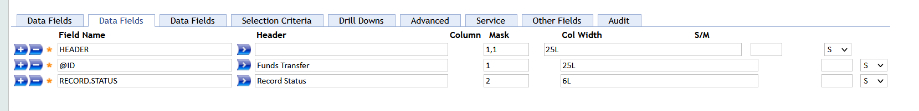

* DRILLDOWN



LOCAL TABEL

LOCAL.REF.TABLE

TEMPLATE LOCAL TABEL

